**ISAD251**

**Database Application**

**Development**

**20 CREDIT MODULE / 50% COURSEWORK SUBMISSION**

**/ 50% EXAM**

**MODULE LEADER: SHIRLEY ATKINSON**

**MODULE LECTURER: WILLIAM PANG**

**STUDENT:**

Name: WONG, WING HO

Student ID: 20042520

1. **Storyboard of Application**

* For Public & Customer

This is the landing page for all people.  
  
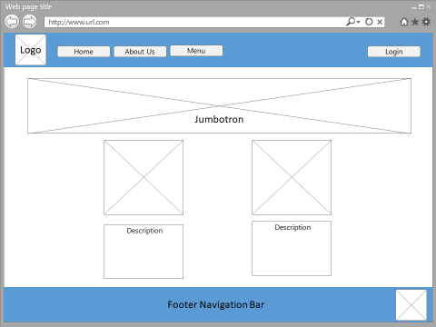

Public will see a “Sign-in” bottom at the “Menu”.  
  
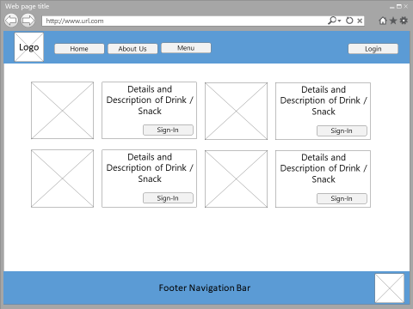

Public are required to sign-up for ordering items.

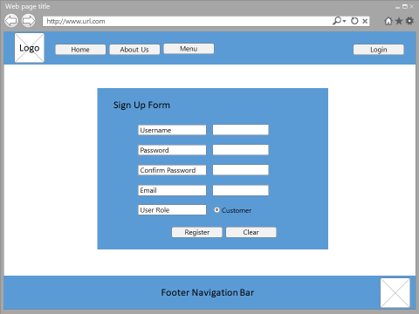

Customer are required to sign-in for ordering items.

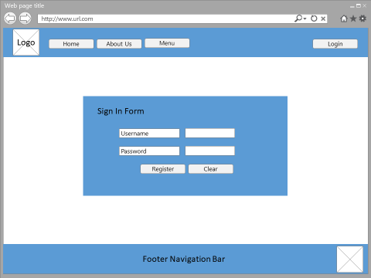

After sign-in, a button “Add to Cart” will be displayed in the Menu Page. Customer can check other added item in the “Shopping Cart” at the top of navigation bar. If customer is ready to checkout, just click “checkout”

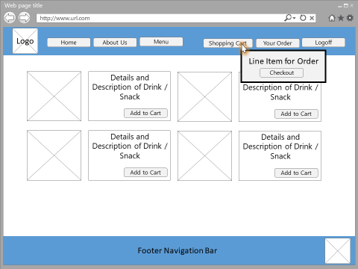

An order form will be displayed. Corresponding line item will be listed.

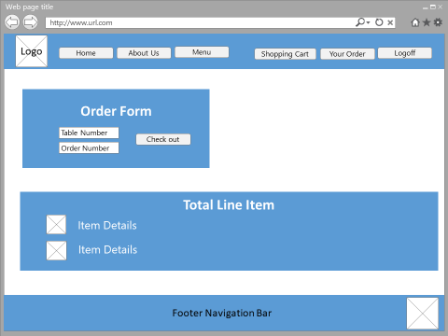

This is the page for customer who want to check their orders.

More details of ordered items can be checked by selecting “OrderDetails” button

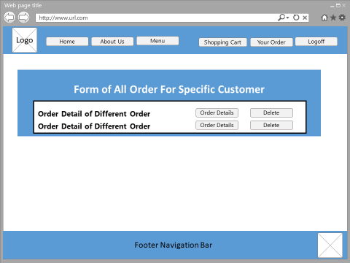

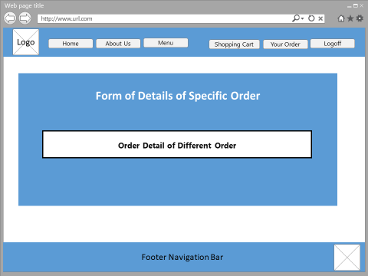

* For Administrator

Administrator is required to log-in.



Two different tab (Product Management & Order Management) will be shown after administrator is logged-in.

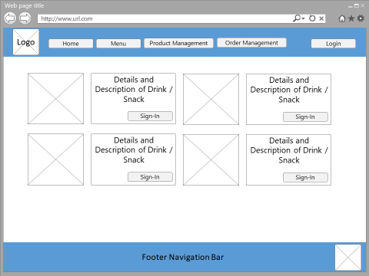

This is the page of product list. Administrator can view details of items, create new items, or edit specific item.

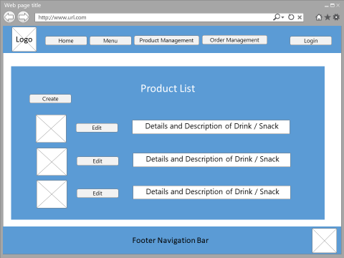

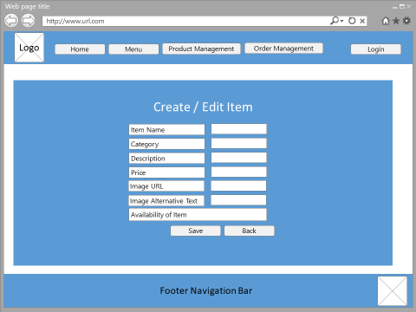

This is the page for administrator who want to check all customers’ orders.

More details of ordered items can be checked by selecting “OrderDetails” button

It also provide a searching function for administrator to search specific user’s order by name.

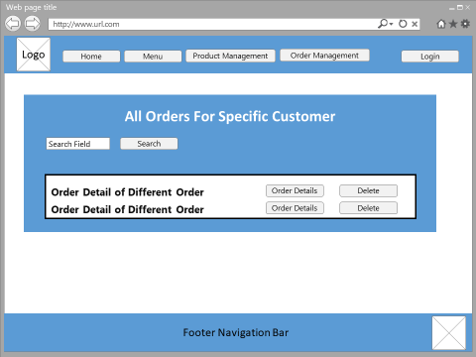

1. **ER-Diagram**

* For Database (BarContext)

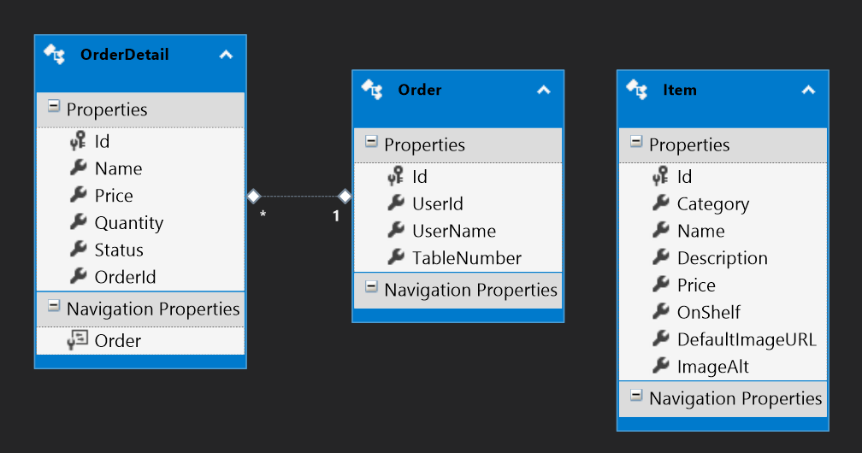

* For Database (Default Connection)

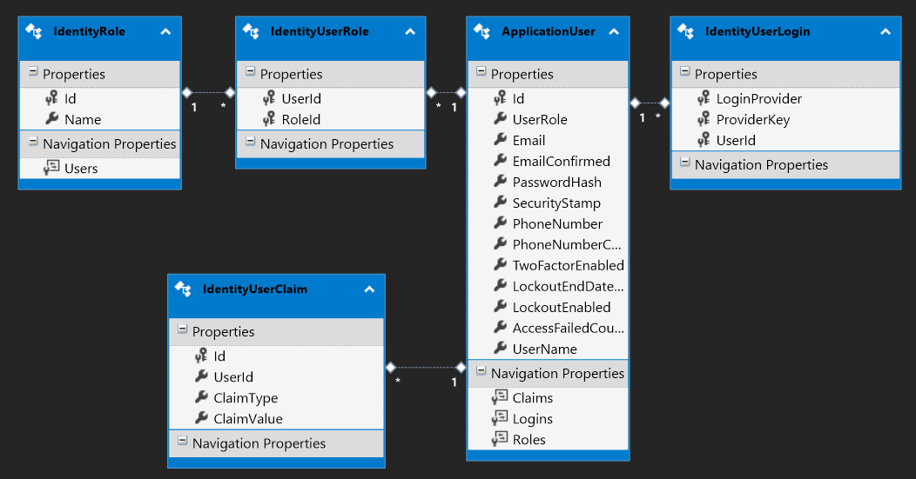

1. **Any Setting and Images**

* For Website Design

|  |  |
| --- | --- |
| C:\Users\whwong\AppData\Local\Microsoft\Windows\INetCache\Content.Word\About_us_jumbotron.jpg | C:\Users\whwong\AppData\Local\Microsoft\Windows\INetCache\Content.Word\bg.png |
| C:\Users\whwong\AppData\Local\Microsoft\Windows\INetCache\Content.Word\jumbotron.jpg | C:\Users\whwong\AppData\Local\Microsoft\Windows\INetCache\Content.Word\recommended_drinks.jpg |
|  |  |
|  |  |

* For Item Product

|  |
| --- |
| C:\Users\whwong\Desktop\Project\V4\FormosBar\FormosBar\Content\img\ItemPhotos\Ardbeg_10.jpg C:\Users\whwong\Desktop\Project\V4\FormosBar\FormosBar\Content\img\ItemPhotos\Glenlivet_18Y.jpg C:\Users\whwong\Desktop\Project\V4\FormosBar\FormosBar\Content\img\ItemPhotos\Lagavulin_16Y.jpg |
| C:\Users\whwong\Desktop\Project\V4\FormosBar\FormosBar\Content\img\ItemPhotos\Mortadella_Pizza.jpg C:\Users\whwong\Desktop\Project\V4\FormosBar\FormosBar\Content\img\ItemPhotos\Haggis.jpg C:\Users\whwong\Desktop\Project\V4\FormosBar\FormosBar\Content\img\ItemPhotos\Buffalo_Wings.jpg |

1. **Evidence of Browser Compatibility**

* Google Chrome  
    
  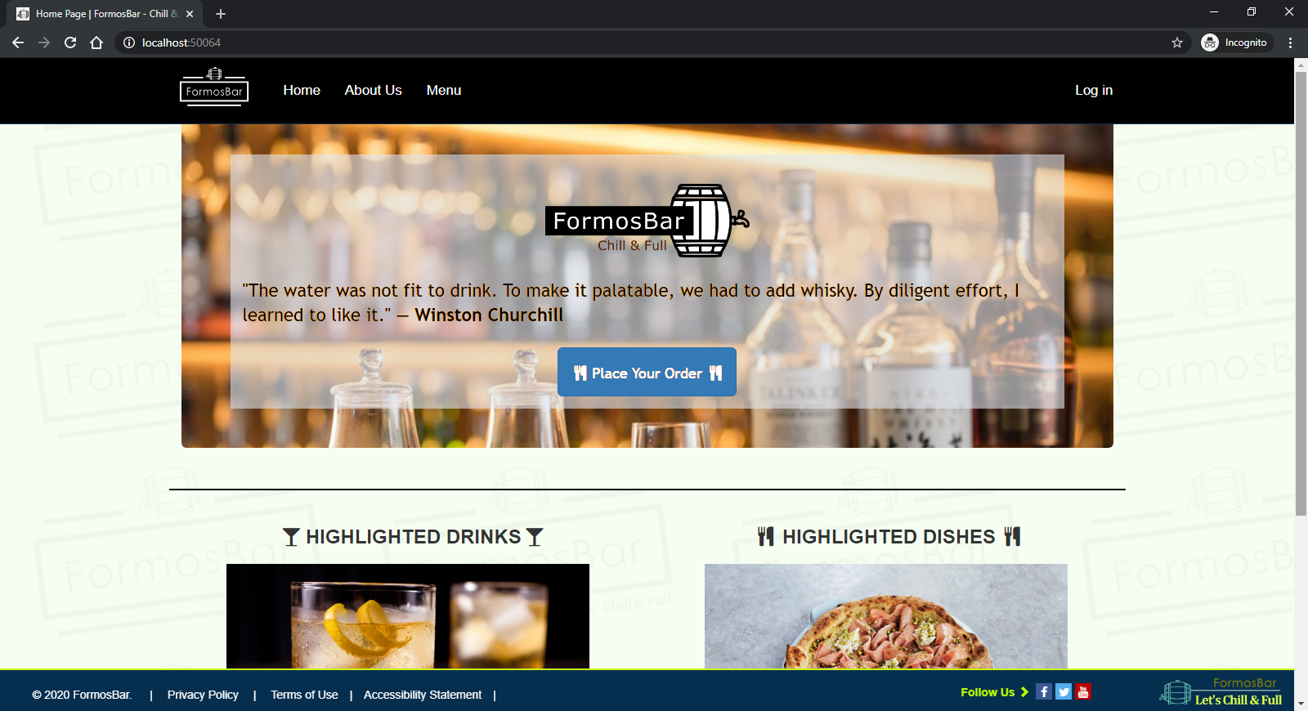  
    
  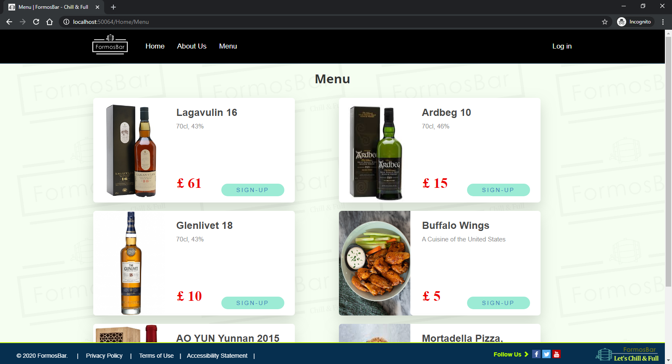
* FireFox  
    
  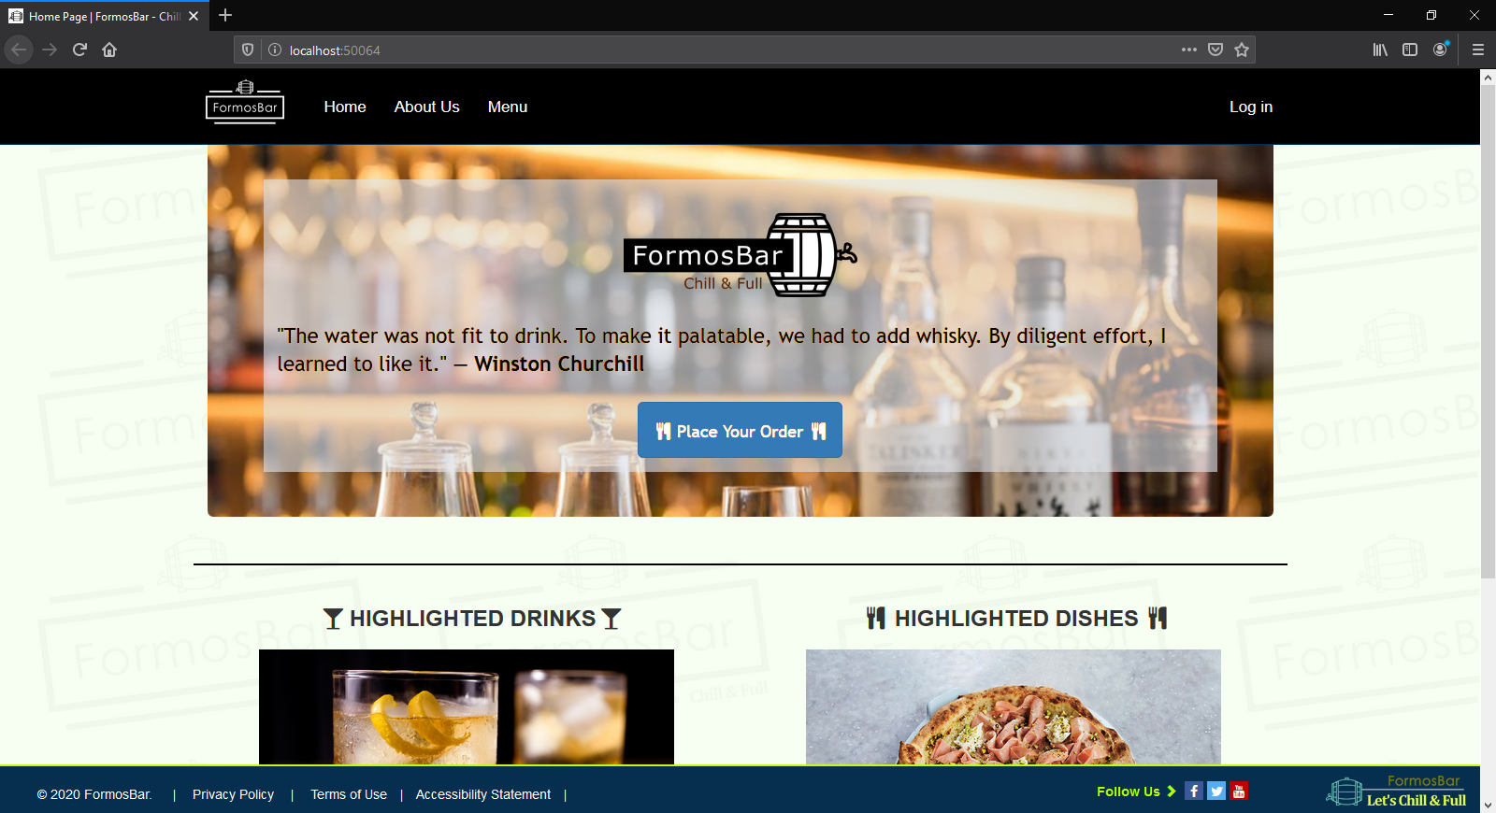  
    
  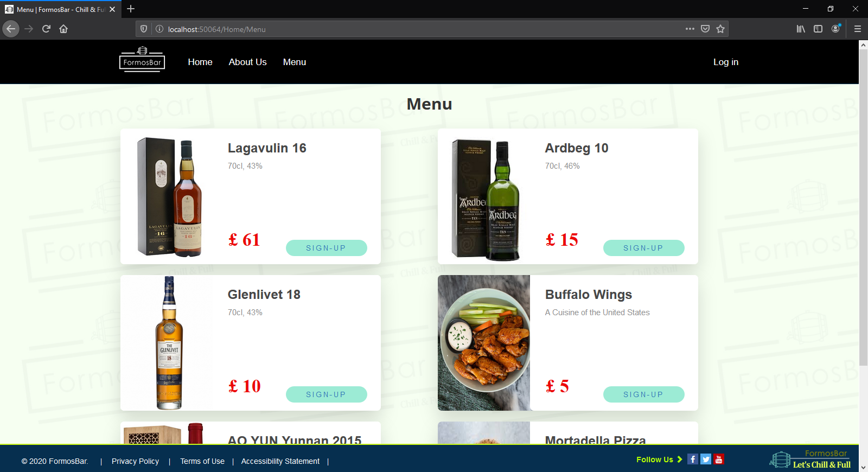

1. **Evidence of using the Web Accessibility Initiative (WAI) guidelines**
2. Using “Alternative Text and Title” (img src=”xx” alt=”xx” title=”xx”) For All Images  
     
   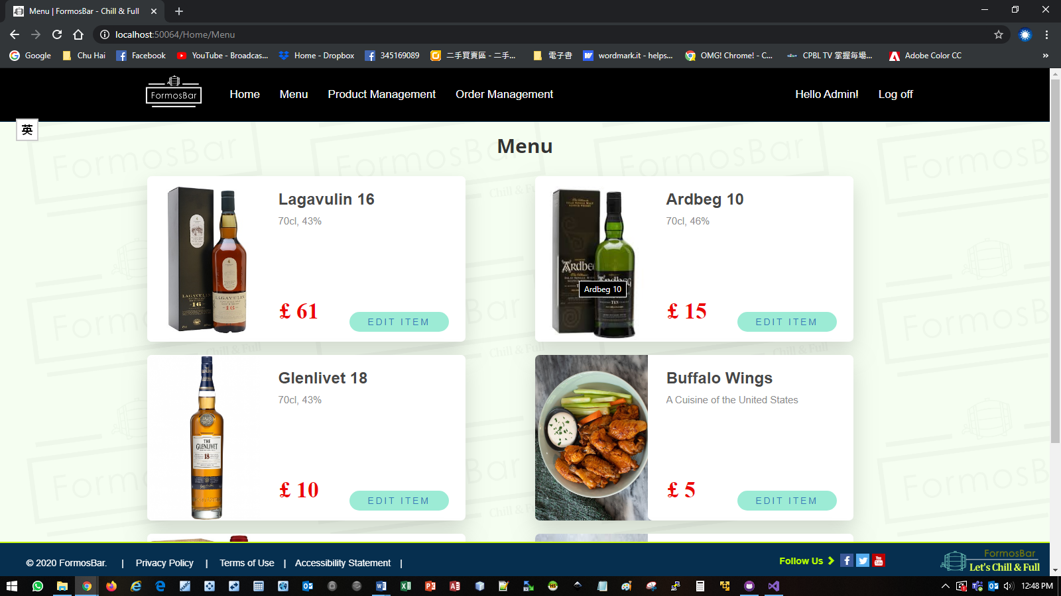   
     
   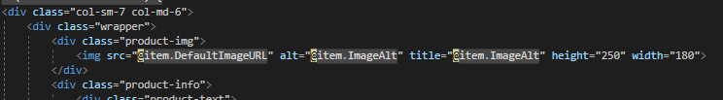  
     
   Commentary: The reason why using “alt” element is for disable person. When they use screen reader to access the webpage, screen reader will provide the exact wording description of that image to them.
3. Using “role = button” and “aria-pressed=”false” For All Buttons  
     
   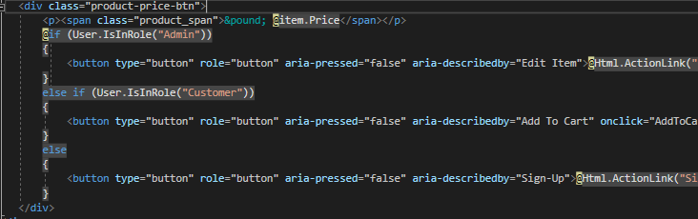  
     
   Commentary: The reason why using these two elements is to let the button appearing as a button control to a screen reader. And the “aria-pressed = “false” helps to indicate to disable person that the button is not currently pressed.
4. **Improvement**

|  |
| --- |
| 1. **Enhancement on Handling “Delete Action” in Administrator’s View** |
| Due to the Referential integrity is important to database, “Delete Action” on Product which is already associated with other table in database is not appropriate. Data Loss will break the referential integrity. In order to enhance the system design to handle this situation, I have removed the delete function. And “Product Hidden Function” is included. Administrator can set “Hide Item” in the form if he/she want to hide this item on the Menu List. This approach allows administrator disabling product item without deleting any related records in the database. It helps maintaining the integrity. |
|  |
| 1. **Enhancement on Handling “Add Item to Current Order’s issue** |

1. **URL’s**

* API Middleware:

1. http://localhost:50064/api/Orders
2. http://localhost:50064/api/OrderDetails

* Hosted Web Page: http://localhost:50064/OrderService/index
* GitHub Repository: <https://github.com/formosa77/FormosBar>

1. **Peer Review (I)**

**Peer Review carried out by:** LAM, Chiang Wai

**Date:** 28 December, 2019

The peer review should pick one of the user stories and attempt to use the application as that type of user carrying out that task. On completing using the application, you should ask the author to describe to you one aspect of the code implemented to run the task – e.g. the database structure or the server-side code.

**Task conducted:**

Administrator performs CRUD actions to Products.

**Was the task easy to carry out?**

For Creation, modification, updating products, actions are easy to perform. Procedures are quite straightforward and user-friendly.

**Did you encounter any errors?**

For the deletion of products, it is not necessary to delete any products. As the deleted product might has already associated with pervious orders, deleting the product record might break the integrity of the order record.

**Did the author have to explain how to use anything?**

No explanation is needed to handle those actions.

**Did you gain any inspiration for your own practice?**

Yes. Using “Item Hiding” instead of “Deleting Product” would be the best practice on handling “D” actions of products.

**What constructive advice would you give the author for presenting their work/code in future?**

System should provide an option to administrator for setting the availability of specific product, such as hiding the product on product list. And the status of availability should be included as a field on the entire product’s list.

1. **Peer Review (II)**

**Peer Review carried out by:** (name)

**Date:** 2 January, 2020

The peer review should pick one of the user stories and attempt to use the application as that type of user carrying out that task. On completing using the application, you should ask the author to describe to you one aspect of the code implemented to run the task – e.g. the database structure or the server-side code.

**Task conducted:**

Customer add new drinks/foods into current order.

**Was the task easy to carry out?**

It is difficult to do this.

**Did you encounter any errors?**

I am not sure how to do the task on adding new items into current order.

**Did the author have to explain how to use anything?**

Yes. Author have explained the entire procedures to do the task. It includes the input of designated “Table Number” and designated “Order Number” to map the correct order.

**Did you gain any inspiration for your own practice?**

Yes. This is one of the possible approach, but better approach is needed.

**What constructive advice would you give the author for presenting their work/code in future?**

Adding a status control on the “Order”.

If the “Order Status” is “Active”, the new item will be allocated into current Order.

Once the customer confirms current order, the Order Status will be switched to “Completed.

If customer submits new item, a blank new order will be created.